Report on the visit of IFHS members to the Ancient DNA laboratory
at the
Smurfit Institute of Genetics at Trinity College Dublin.
Tuesday April 23, 2024 at 2:30 pm.
We had a good turnout of twenty members for the visit to Trinity where Professor Dan Bradley gave us a tour of the laboratories and a presentation on the work that is done there.
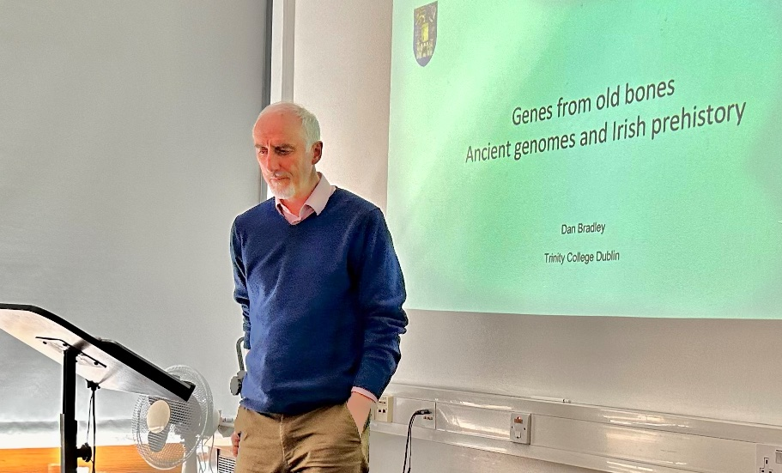
At the beginning of the presentation he outlined the three great changes that took place in Western Europe and in Ireland: the coming of hunter-gatherers at the end of the ice age about 10,000 years ago; the beginning of farming practices about 6,000 years ago, and finally the coming of metallurgy into this stone age population and culture about 4,500 years ago. He challenged us to consider whether these changes were a gradual adoption over many years of cultural practices from the east or whether there was a more sudden cliff-edge transition in each case, with a change in population that accompanied them. His presentation went on to demonstrate that the evidence from ancient DNA that has been extracted and sequenced from ancient bodies in Ireland and across Europe suggests that there were significant genetic changes to the population at each transition.
Up to recently it was archaeology that provided the only scientific evidence about ancient peoples in Ireland. We had a written mythology too, written albeit long after the events they described, in the Lebor Gabála Érenn (literally "The Book of the Taking of Ireland"), or what is called in English "The Book of Invasions". Added to that we perceive of ourselves as a Celtic people, and they first appeared in Europe 2,500 years ago. So who are we and what are our origins?
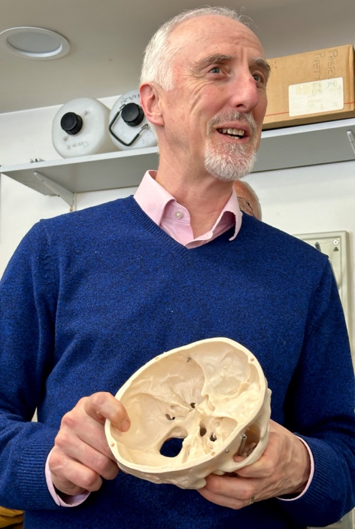
With the first description of DNA in the early 1950s by Watson and Crick based on evidence discovered by Rosalind Franklin a new scientific measure was made possible into the genetic evolution of mankind. This led to the Human Genome project which eventually succeeded in sequencing the whole genetic structure of humans. It was not until 2010 that ancient DNA (aDNA) from human remains became possible and it has revolutionised our view of global migration.
Professor Bradley demonstrated to the group, with a model of the human skull, how ancient DNA (aDNA) is extracted from the Petrus bone which protects the inner ear. The Ancient DNA lab founded by Professor Bradley at Trinity College Dublin is the key scientific resource for discovering who we are in Ireland. His colleagues in the lab, including Dr. Lara Cassidy, have made extraordinary discoveries from the bones of bodies from Puolnabrone dolmen in Co. Clare, the Carrowkeel burials in Co. Sligo, the bodies found during the fifties excavations at Newgrange, and other recent finds in Rathlin Island and Ballyshannon.
One such finding is summarized in this abstract of an article in Nature by Dr. Bradley, Dr. Lara Cassidy and others:
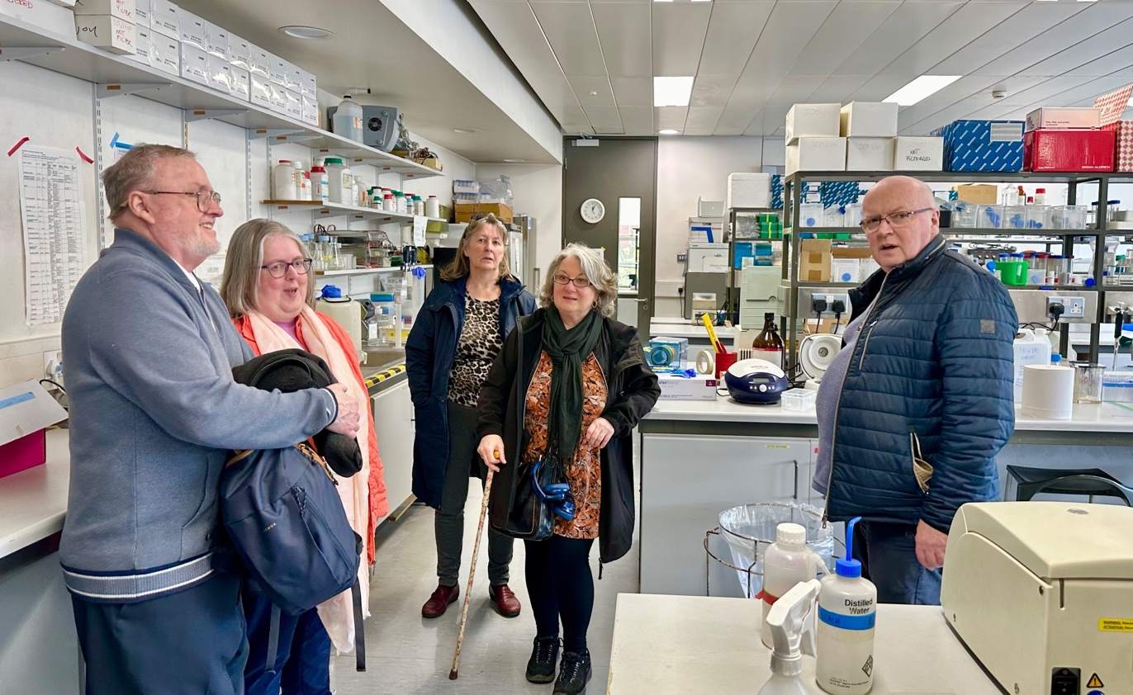
"The scale and sophistication of megalithic architecture along the Atlantic seaboard, culminating in the great passage tomb complexes, is particularly impressive. Although co-operative ideology has often been emphasised as a driver of megalith construction, the human expenditure required to erect the largest monuments has led some researchers to emphasize hierarchy — of which the most extreme case is a small elite marshalling the labour of the masses. Here we present evidence that a social stratum of this type was established during the Neolithic period in Ireland. We sampled 44 whole genomes, among which we identify the adult son of a first-degree incestuous union from remains that were discovered within the most elaborate recess of the Newgrange passage tomb. Socially sanctioned matings of this nature are very rare, and are documented almost exclusively among politico-religious elites specifically within polygynous and patrilineal royal families that are headed by god-kings. We identify relatives of this individual within two other major complexes of passage tombs 150 km to the west of Newgrange (Carrowmore and Carrowkeel in Co. Sligo), as well as dietary differences and fine-scale haplotypic structure (which is unprecedented in resolution for a prehistoric population) between passage tomb samples and the larger dataset, which together imply hierarchy. This elite emerged against a backdrop of rapid maritime colonization that displaced a unique Mesolithic isolate population, although we also detected rare Irish hunter-gatherer introgression within the Neolithic population." (from A dynastic elite in monumental Neolithic society. https://www.nature.com/articles/s41586-020-2378-6 )
Professor Bradley went on to describe how DNA testing of ancient bodies in Ireland suggest that there was a Neolithic and a bronze age migration of peoples into Ireland and that the Bronze age migration about 4,500 years is what makes up the majority of the Irish genome today. This extract from another paper from the lab summarizes the results:
"Modern Europe has been shaped by two episodes in prehistory, the advent of agriculture and later metallurgy. ...... The first ancient whole genomes from Ireland, including two at high coverage, demonstrate that large-scale genetic shifts accompanied both transitions. We also observe a strong signal of continuity between modern day Irish populations and the Bronze Age individuals, one of whom is a carrier for the C282Y hemochromatosis mutation, which has its highest frequencies in Ireland today.
....... We address this issue by using the first whole genome data from prehistoric Irish individuals. A Neolithic woman (3343–3020 cal BC) from a megalithic burial (10.3× coverage) possessed a genome of predominantly Near Eastern origin. She had some hunter–gatherer ancestry but belonged to a population of large effective size, suggesting a substantial influx of early farmers to the island. Three Bronze Age individuals from Rathlin Island (2026–1534 cal BC), including one high coverage (10.5×) genome, showed substantial Steppe genetic heritage indicating that the European population upheavals of the third millennium manifested all of the way from southern Siberia to the western ocean. This turnover invites the possibility of accompanying introduction of Indo-European, perhaps early Celtic, language. Irish Bronze Age haplotypic similarity is strongest within modern Irish, Scottish, and Welsh populations, and several important genetic variants that today show maximal or very high frequencies in Ireland appear at this horizon. These include those coding for lactase persistence, blue eye colour, Y chromosome R1b haplotypes, and the hemochromatosis C282Y allele; to our knowledge, the first detection of a known Mendelian disease variant in prehistory. These findings together suggest the establishment of central attributes of the Irish genome 4,000 y ago." (from Neolithic and Bronze Age migration to Ireland and establishment of the insular Atlantic genome: https://www.pnas.org/doi/full/10.1073/pnas.1518445113 )
The work of the Trinity lab will continue to provide new evidence as ancient bodies are discovered in Ireland - already the lab is working on bodies from Knowth, and from the newly discovered medieval graveyard at the bypass road works at Ranelagh townland near Roscommon town. As family historians look to DNA testing, and especially to Y and mtDNA testing that measure ones patriarchal and matriarchal ancient heritage we will get a clearer picture of the ancient migrations into Ireland. We might even discover plausible signs that the Tuatha Dé Danann were real people - turning stone to copper would seem magical when first witnessed!
